Pickleball Information 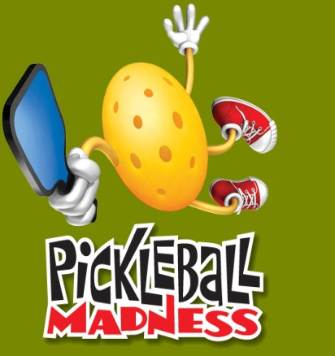

What is Pickleball:
- Pickleball is a mini tennis like game that has gained popularity among people of all ages. The game was invented by U.S. Congressman Joel Pritchard, William Bell and Barney McCollum. They had wanted to create a recreational sport that the whole family could enjoy together. They named the sport Pickle-ball after the congressman’s dog, “Pickles”, who chased the ball for them from time to time.
- Pickleball is very similar to badminton in the way it is played.

The Game:
- The ball is served underhand and is served diagonally to the opponent’s service court.
- Points are scored by the serving side only and occur when the opponent faults.
- The serving team continues to serve, altering service courts, until the serving team faults.

The Serve:
- The serve is made underhand-the paddle must pass below the waist.
- The serve is made diagonally cross court and must clear the non-volley zone.
- Only one serve attempt is allowed.
- In singles you serve from the right if you have an even score and left if your score is odd.

The Volley:
- To volley a ball means to hit it in the air without first letting it bounce. All volleying must be done with the player’s feet behind the non-volley zone line.

Double Bounce Rule:
Each team must play their first shot off the bounce. That is, the first receiving team must let the served ball bounce, and the serving team must let the return of serve bounce before playing it. After the two bounces have occurred, the ball can be either volleyed or played off the bounce.

Faults:
- Hitting the ball out of bounds
- Not clearing the net
- Stepping into the non-volley zone and volleying the ball
- Serving to the wrong person

The Court:
- Court dimensions for pickleball are the same as in badminton.
- The net is hung 36” in each end and 34” in the middle.
- The non-volley zone extends 7’ on each side of the net.

